

|  |
| --- |
| ASSIGNMENT NO.1  OOP |
| SUBMITTED TO : Sir Shahid Bhatti |
| Submitted By : Maham Iftikhar  Roll No : SP24-BSE-056 |

Messaging App(classes,attributes,Functions)

# 1. Sms Class

The ‘Sms’ class given below encapsulates elements of a text message and has a number of fields to contain information about the message.

# Attributes:

* messagecontent (String): Remembers the content of the message.
* status (boolean): Shows whether or not the message was read or not.
* messageid (String): Identifier for the message to be used in the service to identify the message.
* datetime (LocalDateTime): Saves the time and date at which the message was sent.
* idcounter (static int): Opposite to build the unique message IDs.

# Methods:

* Sms (String messagecontent): The constructor used which creates a new message with Content, sets ID, and date and time.
* getMessageid(): Returns the message-ID of the current message as a string.
* getDatetime(): Tells the date and time of the message.
* status(): Used to set the status to true, in order to mark the message as read.
* meassagestatus(): Blank if status is 0, and “Read” if the status is anything else than 0.
* toString(): This function will return the string representation of the message containing up to four fields: content, status, Id,-formatted date and time.

# 2. Messageapp Class

The 'Messageapp' class manages contacts and their corresponding chats. It includes operations such as adding, deleting, and displaying contacts, as well as sending, searching, and deleting messages.

# Attributes:

* + contact[][](String): 2D array that stores contact details (ID, name, number).
  + chats[][]`(Sms): 2D array that stores messages (Sms objects) for each contact.
  + sendername (String): Name of the sender, fixed as "Maham".
  + sendernumber (String): Phone number of the sender.
  + contactcount (int): Keeps track of the number of contacts.
  + chatcount[] (int): Array that tracks the number of messages for each contact.

# Methods:

* + addedcontact(String name, String number): Initializes some default contacts.
  + addcontact(String name, String number): Adds a new contact to the contact list.
  + findname(String name): Searches for a contact by name and returns its index.
  + Displaycontact(): Displays all saved contacts.
  + deleteContact(String name): Deletes a contact by shifting elements of the array.
  + sendmsg(String name): Sends a message to the specified contact
  + searchchats(String name): Searches and displays the chat history with the given contact.
  + bubbleSortMessagesByTime(Sms[] messages): Sorts messages by date and time.
  + Dispaychats(): Displays chats with all contacts.
  + deletemessage(String name, String messageid): Deletes a message by its ID.

# 3.Main class

* Displays menu
* Uses switch statement to use different functions

# Sample outputs of different functions:

* Menu:

* Add contact:

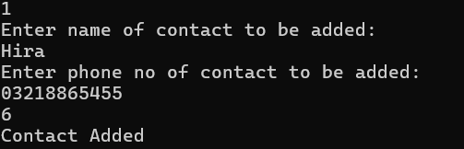

* 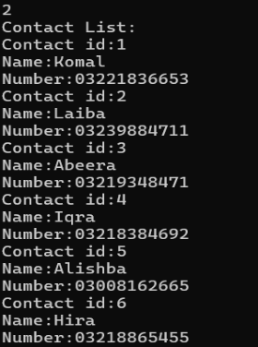Display contact list:
* Delete contact:

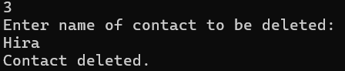

* Display now:

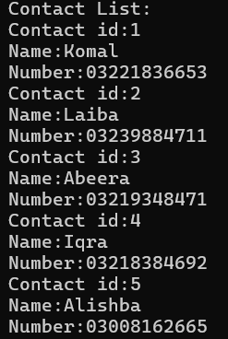

* Send message:

* Search messages(displaying messages of specific contacts sorted in descending order)  
  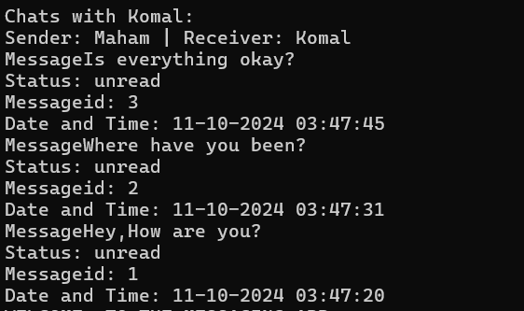
* Display all chats(Both seen and unseen messages):

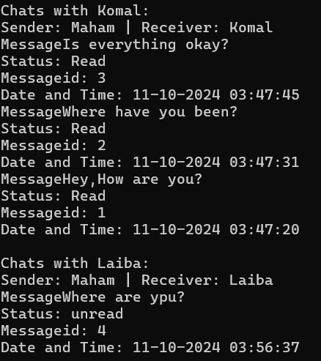

* Delete chat:

